**Personas**

Social People (Sasha)

* Sasha is a social person
* Wants to keep up with friends, by gathering them on a zoom call and playing a game together
* Wants to have fun and interact with people face-to-face

Bored people (Boris)

* Somewhat bored in meetings
* Cares about grades and classes, but sometimes just needs a distraction from virtual lectures
* Wants something mindless/non-distracting so they can pay attention to meetings too
* Just wants something to do on the side where they can chat with classmates a bit like they would in their in-person classes

(?) Really Bored People (Reid)

* Cares little for their meetings
* Wants to play invested games with other people in the meeting without interrupting it

**Use Cases**

*A use case for starting a multiplayer game on zoom, the actors are the host of the game and other players*

1. The user presses a button to load a screen to select a game
2. The user chooses a game to play that is multiplayer
3. The user chooses to open the game to the entire call, or select certain people
4. The user sets the game’s options
5. The user invites other players to the call
6. The other players join the game
7. The host user starts the game

Alternative courses:

3. If the number of players is invalid, either not enough or too many

3.1 The system displays an error message

3.2 The system returns to step 3

6. If the players try to join and the host has canceled the game

6.1 The system displays an error message

6.2 The system returns to step 1

*A use case for starting a turn-based game in chat, the actors are the two players*

1. A user presses a button to load a screen to select a game
2. The user chooses a game to play that is turn-based
3. The user sets the game’s options
4. The user plays their first move
5. The user sends the result and next move to the other player
6. The other player begins to play and sends their results back

Alternative courses:

5. If there are no valid users to send a game to

5.1 The system displays an error message

5.2 The system returns to step 1

6. If the other player has left the call

6.1 The system displays an error message

6.2 The system returns to step 1

**Persona Scenarios**

*Boris and The Obstacle Course*

· Boris is getting tired of listening in his meeting and needs a quick break

· He decides to send an invite to a couple of classmates to play the Obstacle Course Game

· After a couple of minutes, he gets a few responses from his classmates saying they accept and want to join the game

· Boris starts the game and a small panel opens up on their screen, where the meeting is still visible

· The game starts and Boris and his classmates control their avatar and navigate the course

· Boris destroys them in the game, the game concludes eliminating the small panel, and they all refocus on class

*Sasha and Mafia*

· Sasha is done with classes and is at home for the semester and misses her friends

· She coordinates a zoom call with her friends, and they all agree to play Mafia

· Sasha initiates the game

· The game secretly assigns roles to all of the players, either a mafia member or an innocent civilian

· The game handles the progression of each round of the game, as in blacking out the screens and facilitating voting

· Since mafia is a social game, Sasha is able to have fun and socialize with her friends

*Boris and Hangman*

· Boris is bored in class once again and decides he wants to play a quick game of hangman with a couple of his classmates

· They agree to play, and Boris initiates the game

· The game randomly creates a phrase for the players to figure out

· A small panel appears on their screens, displaying length of the phrase and the hangman

· Each player takes turns guessing letters, communicating in the chat about which letters to guess

· Boris absolutely dominates, the game concludes, and they refocus on class

*Reid and Slither.io*

· Reid is in a meeting, but has no interest in paying attention

· He invites the whole class to a game of slither.io, to see who can get the highest score by the end of class

· He initiates the game with those that joined, and a panel where they will control their snakes

· The game requires significant attention, so Reid succeeds in being completely distracted from class

· At the end of class Reid concludes the game, and the leaderboard is displayed, and Reid secures his 876th victory

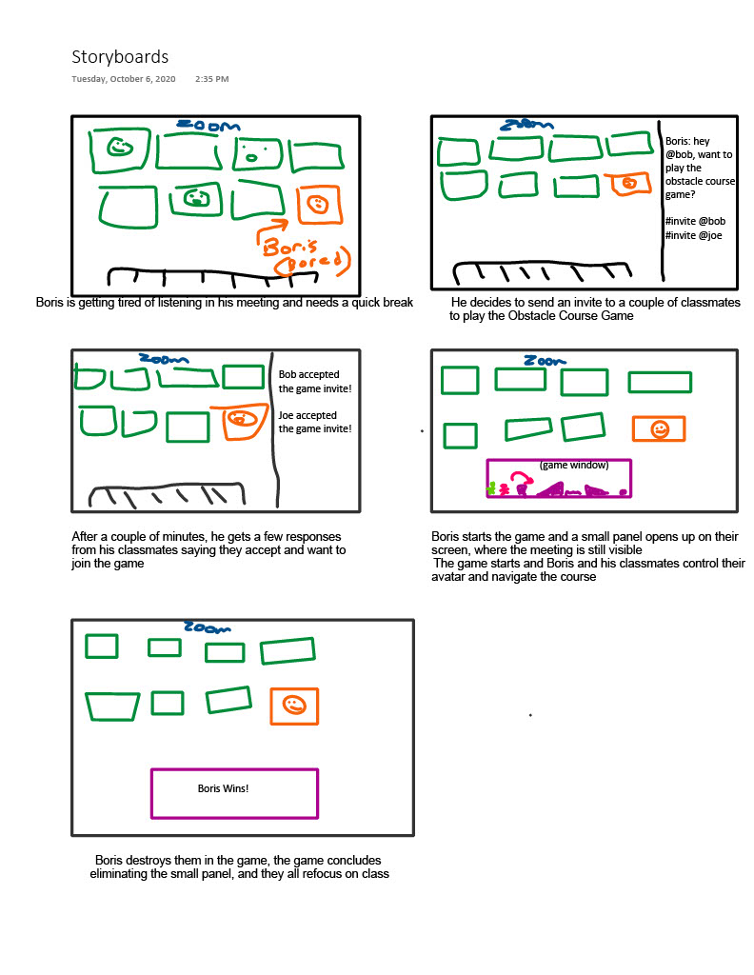

**Mood Board**

